**ASSIGNMENT - 10**

**PROBLEM STATEMENT** - Deploy a project from GitHub to EC2 by creating a new security group and user data.

To Deploy the Project from GitHub to EC2 by creating a new Security Group

STEP 1- Select EC2 option.

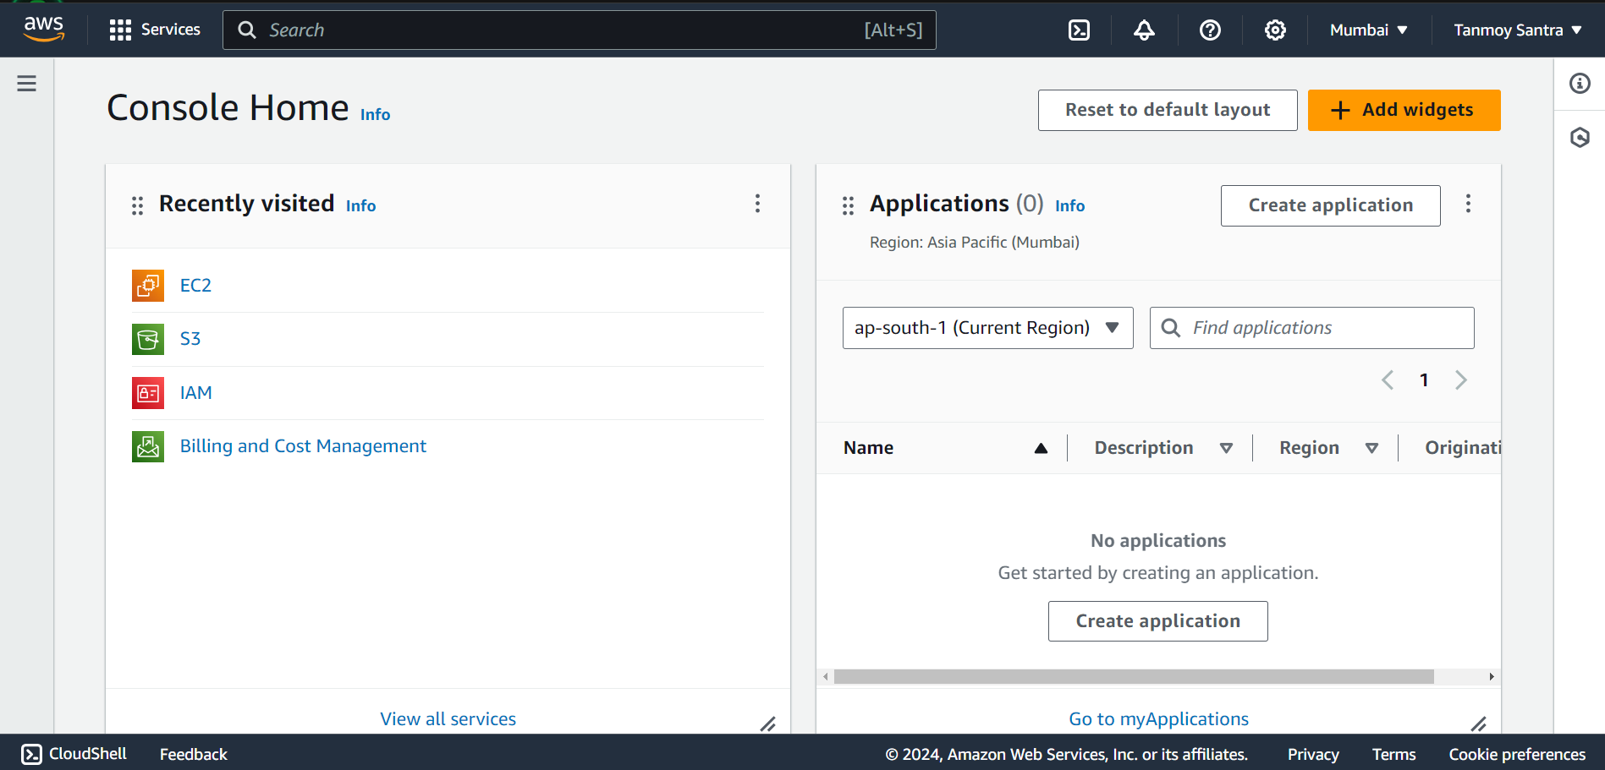

STEP 2- Go to the Security Groups option.

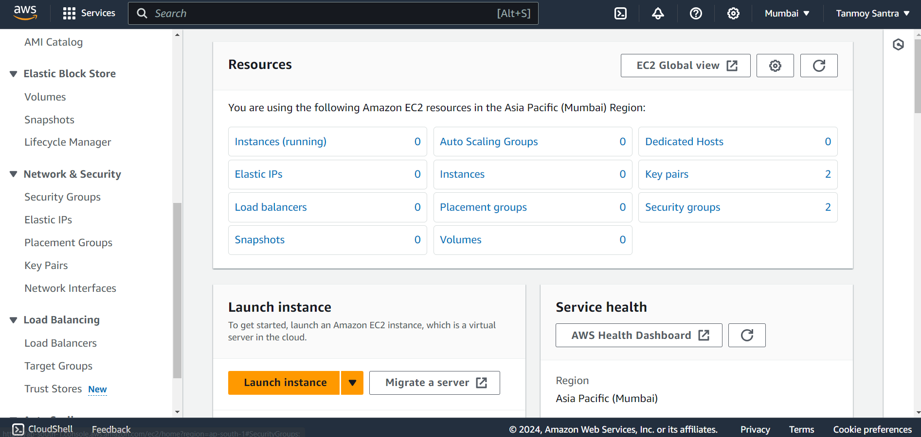

STEP 3- Click on Create Security Group.

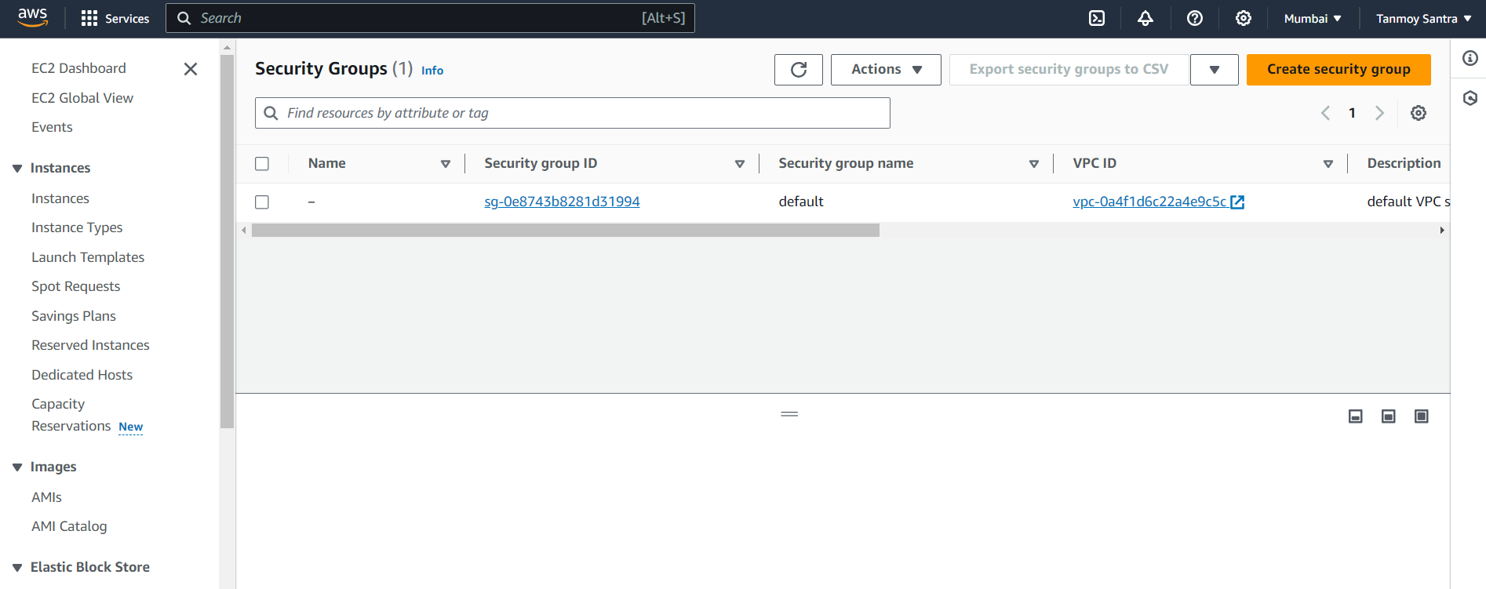

STEP 4- Giva a name and Description to the Security Group. Then click on Add Rule under the

Inbound Rules tab.

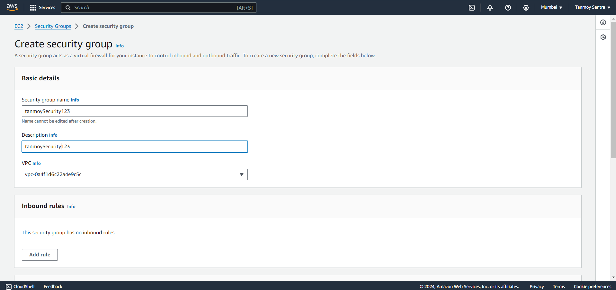

STEP 5- Add the following 4 rules. Give all the rules the source address of 0.0.0.0/0 & and Port range

of 4000 to Custom TCP.

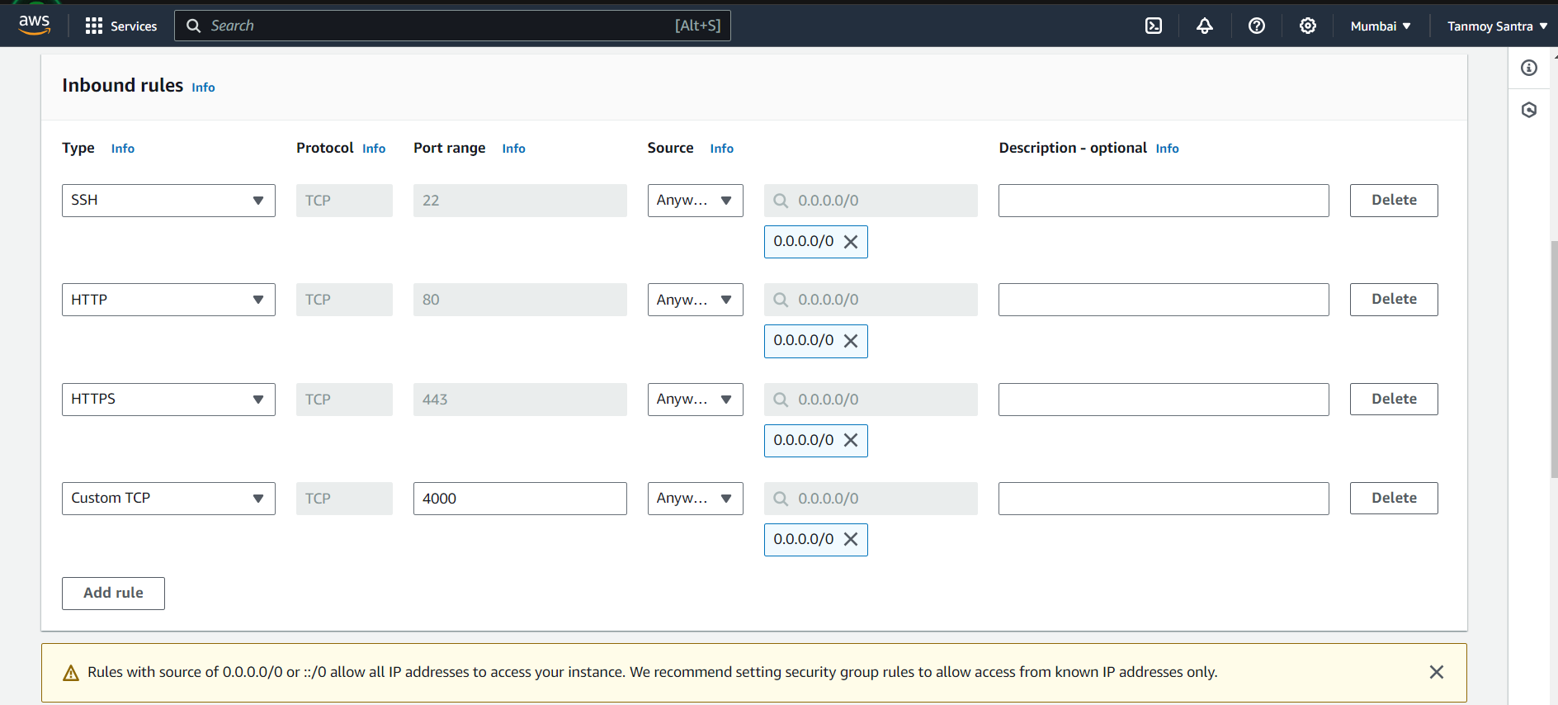

STEP 6- Click on Create Security Group.

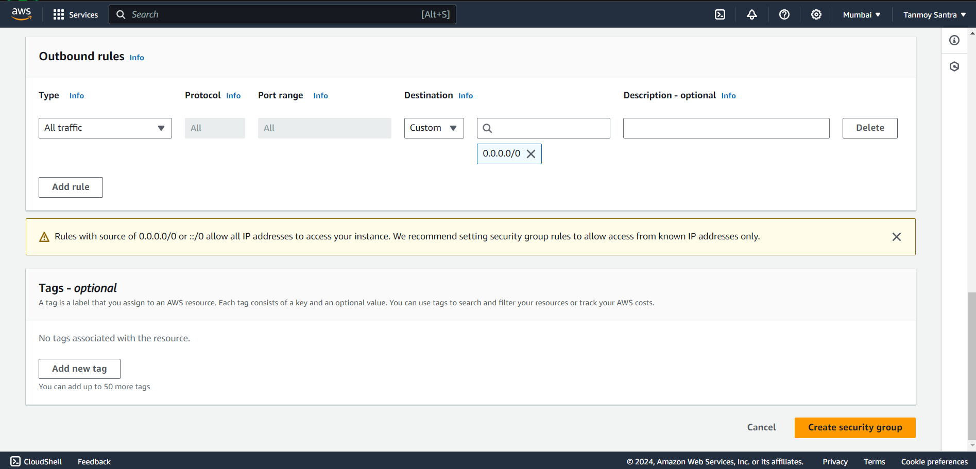

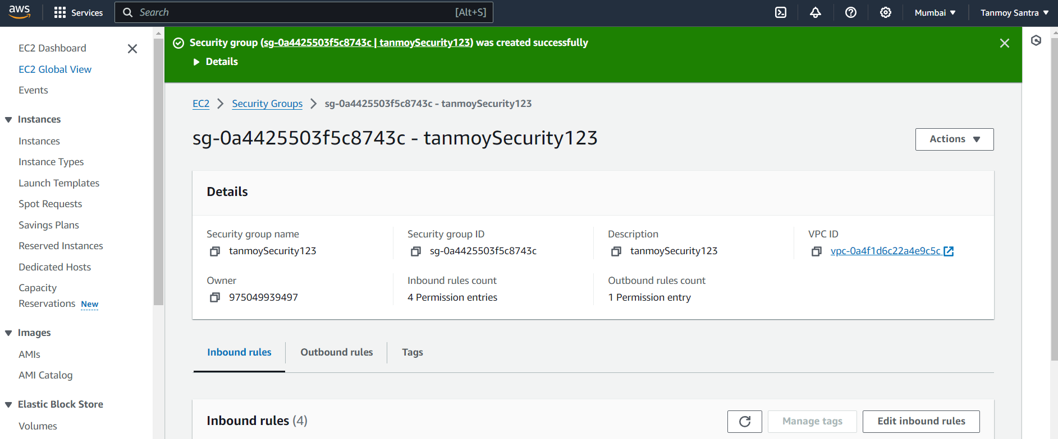

STEP 7- Now click on “Launch Instance”.

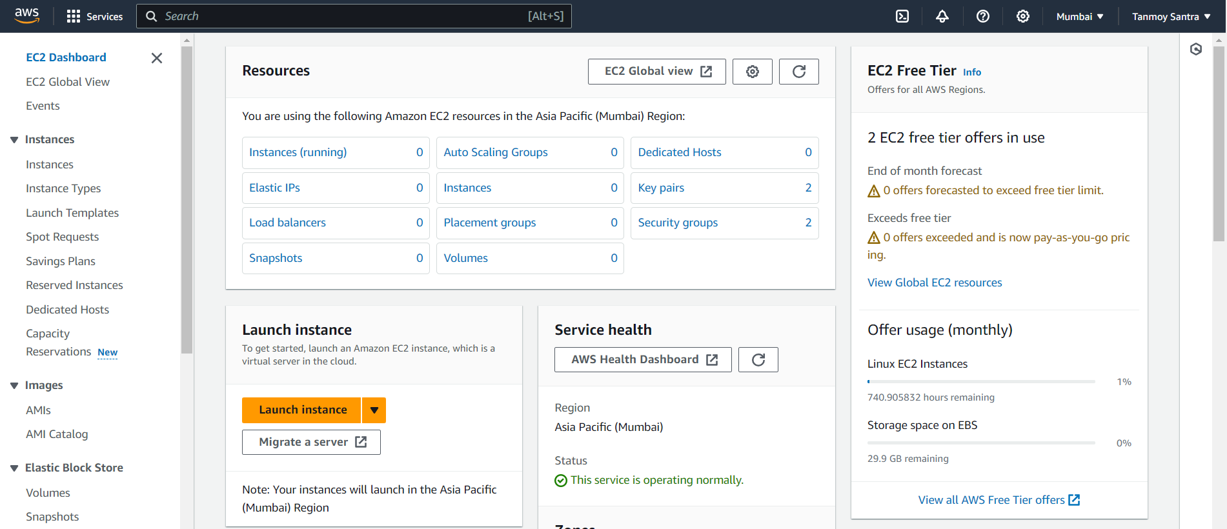

STEP 8- Give a unique name to the instance and select Ubuntu.

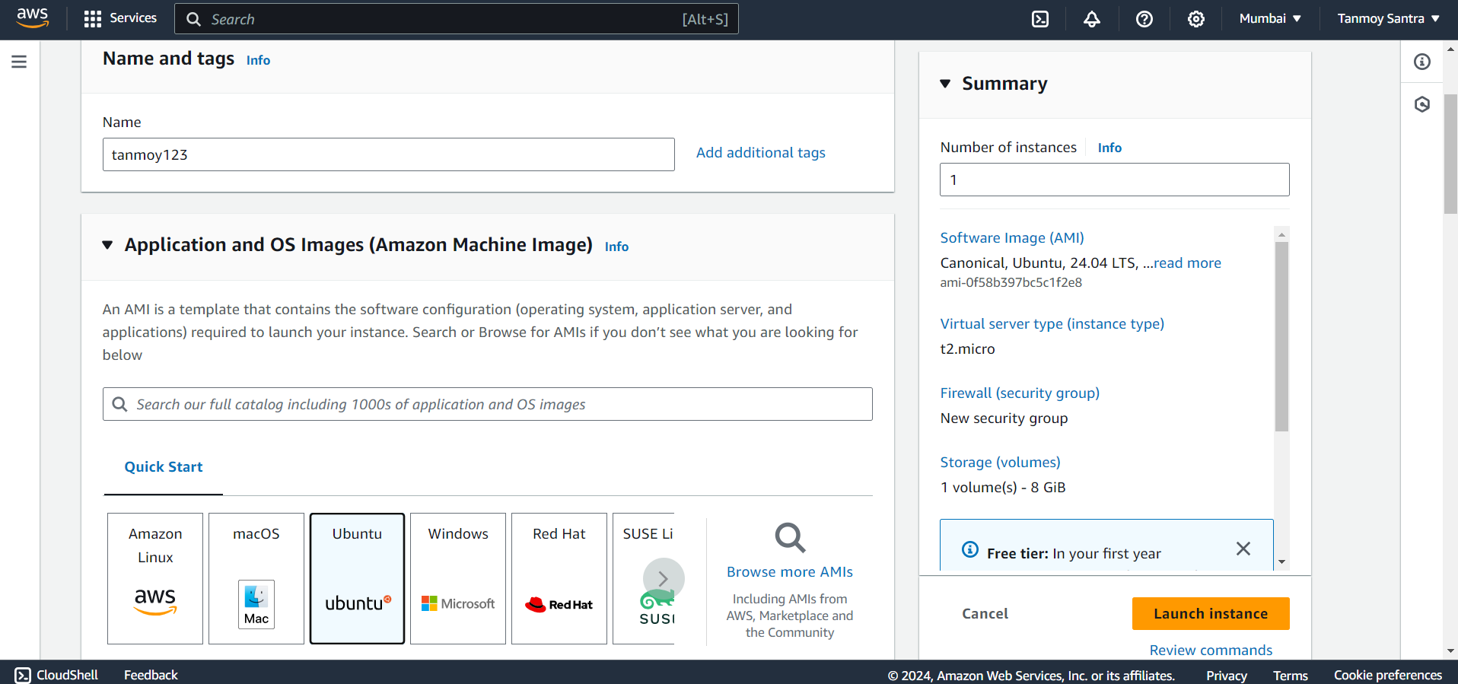

STEP 9- Under key pair (login) select an existing key from the drop down menu or create a new key.

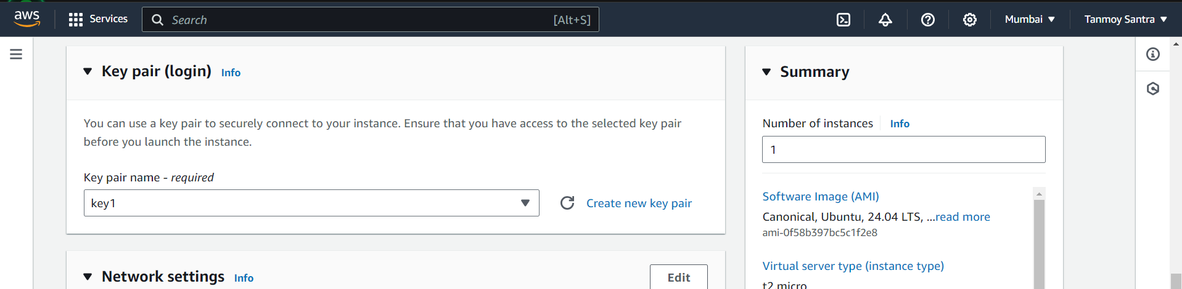

STEP 10- Select the Select Existing Security Group, then select the newly created security group.

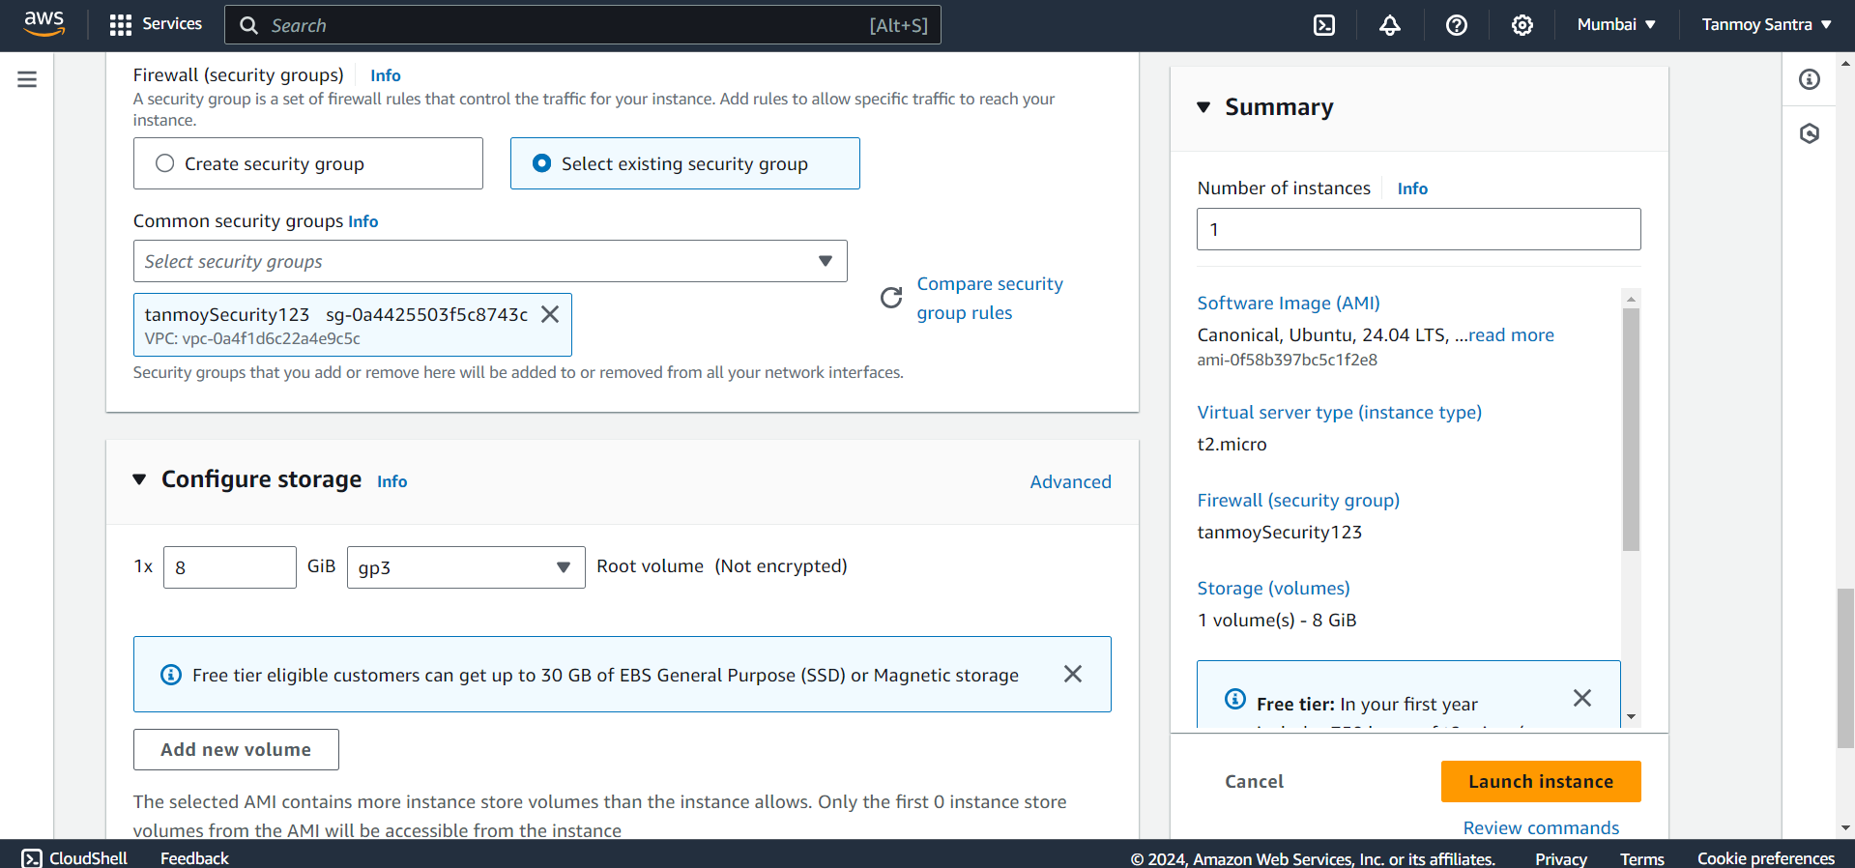

STEP 11- Expand the Advanced Details tab.

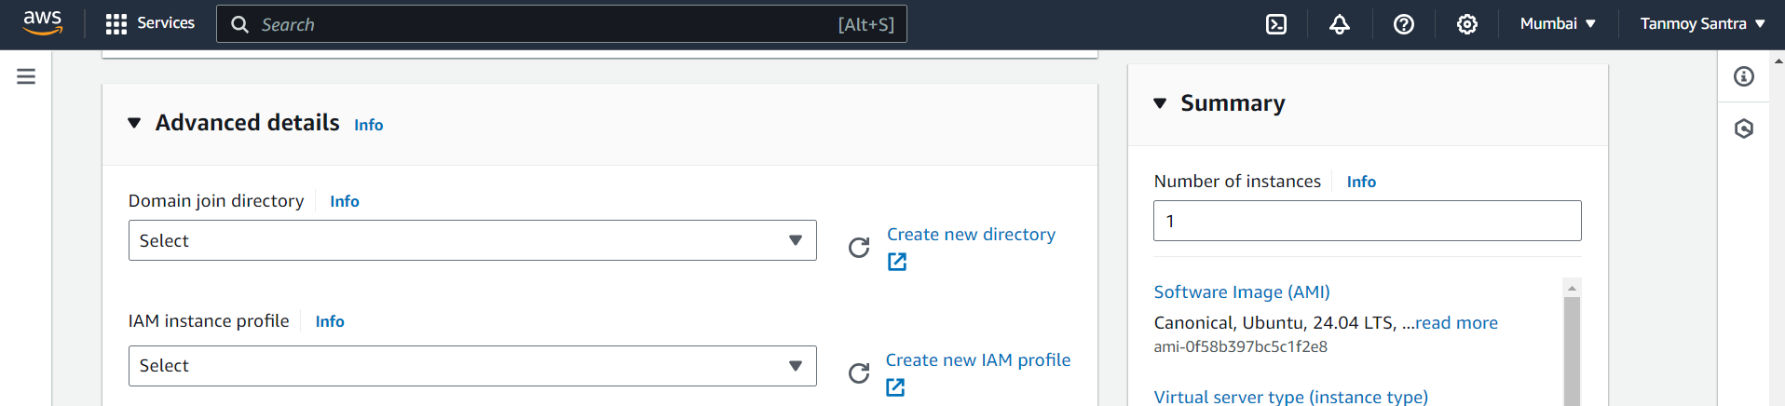

STEP 12- Scroll down to the bottom, in the bash console type the following commands. Then click on

“Launch Instance”.

#!/bin/bash

apt-get update

apt-get install -y nginx

systemctl start nginx

systemctl enable nginx

apt-get install -y git

curl -SL https://deb.nodesource.com/setup_16.x|sudo -E bash -

apt-get install -y nodejs

git clone http://github.com/sudip7407/Repo1.git

cd Repo1

npm install

node index.js

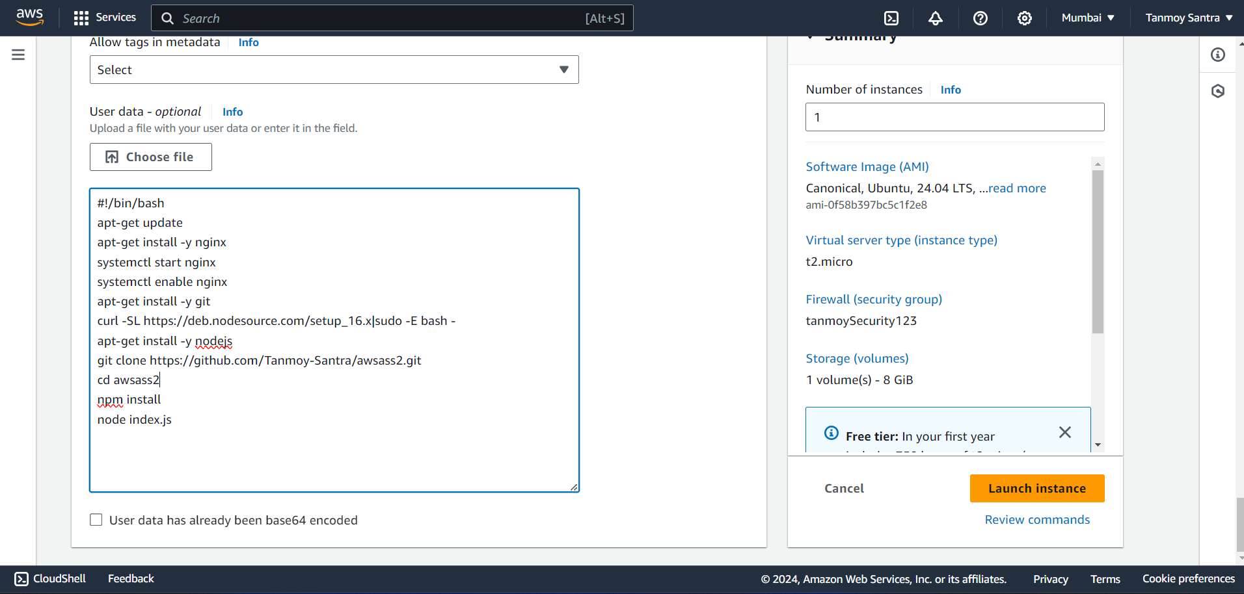

STEP 13- Click on instance id to enter into the instance.

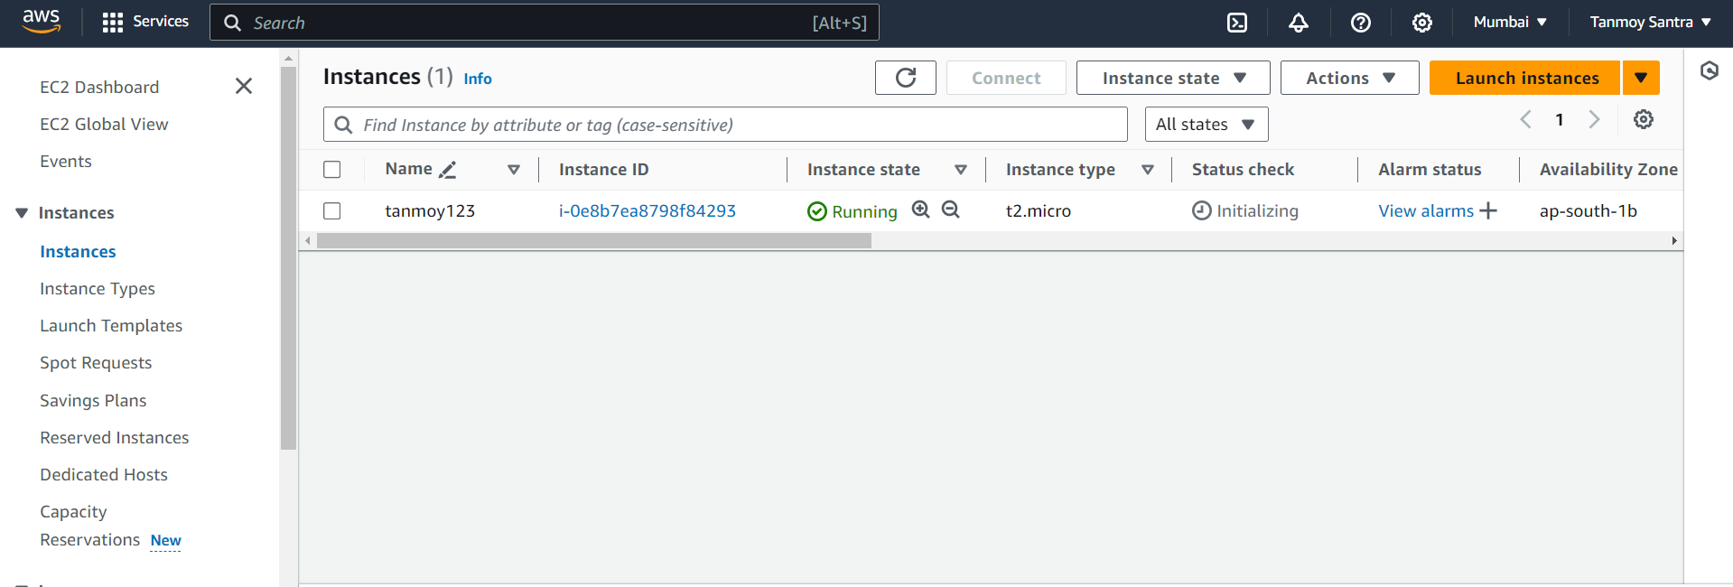

STEP 14- Copy the Public IPv4 Address.

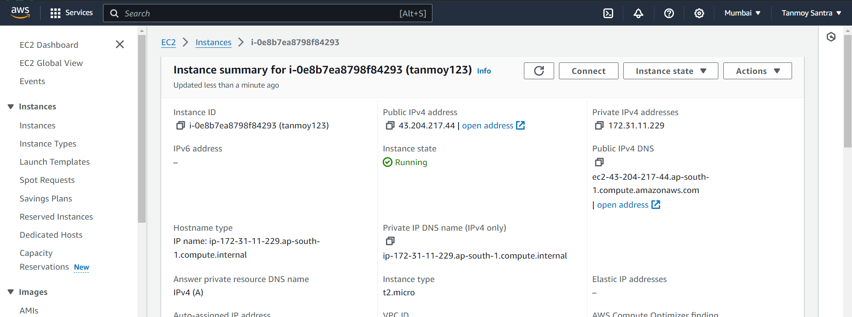

STEP 15- Paste the IP-Address in a new Window. Nginx window will open.



STEP 20- The Nodejs file content will be visible. Now add “:4000” at the end of the IPv4 Address.

